Simulation execution phases and times of function evaluation¹

Simulation time-step start
Inputs
Start River Operations mode
Run forecasting phase for models which do not use functions
Run functions – where evaluation time equals StartOfTimeStep
Run forecasting phase for models which do use functions
River Operations: override expressions and forecast values
Plugins: notify of start of time-step
Run functions – where evaluation time equals Resource Assessment (evaluates once per Resource Assessment system²)
Initialise Resource Assessment systems
Process Water Users
For each water user:
Evaluate “Order Phase” Functions used at water user
Evaluate and distribute demand for water user
Run Constraint phase
For each network element:
Evaluate constraints at element and pass constraint(s) downstream
Run Ordering phase
Evaluate “Order Phase” Functions not used at a network element
For each network element:
Evaluate “Order Phase” Functions used at this network element
Evaluate regulated orders and pass upstream
Evaluate off allocation orders and pass upstream

Evaluate “Flow Phase” Functions not used at a network element
For each network element:
Evaluate “Flow Phase” functions used at this network element
Water ownership – pre-timestep phase³
River management - pre-flow phase
Solve the wetland cluster
Execute flow phase
Water ownership – post-timestep phase
River management - post-flow phase
Calculate constraint factors
Constituent modeling
Evaluate “Post Flow Phase” functions
Finalise Resource Assessment
End of constituent management
Format tabular editor according to End of Time Step values
End forecasting phase
Run functions – where evaluation time equals EndOfTimeStep
Run functions – where evaluation time equals PostFunctionEvaluation⁴ (available for modelled variables only)
Output values written to recorders⁵
Plugins: notify of end of time-step
Simulation time-step end

Notes:
¹ The relevant Time of Evaluation (ToE) is underlined.
² If there is no resource assessment systems setup, then no functions will be evaluated here.
³ Ownership is a layer added to the flow phase that tracks the ownership of water. Information needs to be extracted both before and after the flow phase and for this reason, a separate process is executed for both.
⁴ Post function evaluation is only available for modelled variables. The case where you would use this is if you had a function that needed to be evaluated at the end of the time-step, but you wanted a modelled variable that pointed to this function to be evaluated with the new value – so would set it to “post function evaluation”
⁵ End of Time Step function evaluation was previously done after the application recorded the time step values. This lead to the problem that if you recorded a function that was evaluated at End of Time Step, the recorded value was captured before all the required values had been calculated and was not necessarily what was actually being used in the function at that time of evaluation. Therefore, values are now recorded after all the phases are run and directly before the end of the time-step.
Also, more evaluation times have been added to focus on specific values/requirements.
Some examples from the Goulburn monthly model:
- This function uses the modelled variable ‘Percent Per Share Entitlement’ which is calculated during Resource Assessment (RA) as shown in Figure 1a. Figure 1b compares what the results will be if this same function is evaluated at Start of Timestep (SoT) or End of Timestep (EoT).
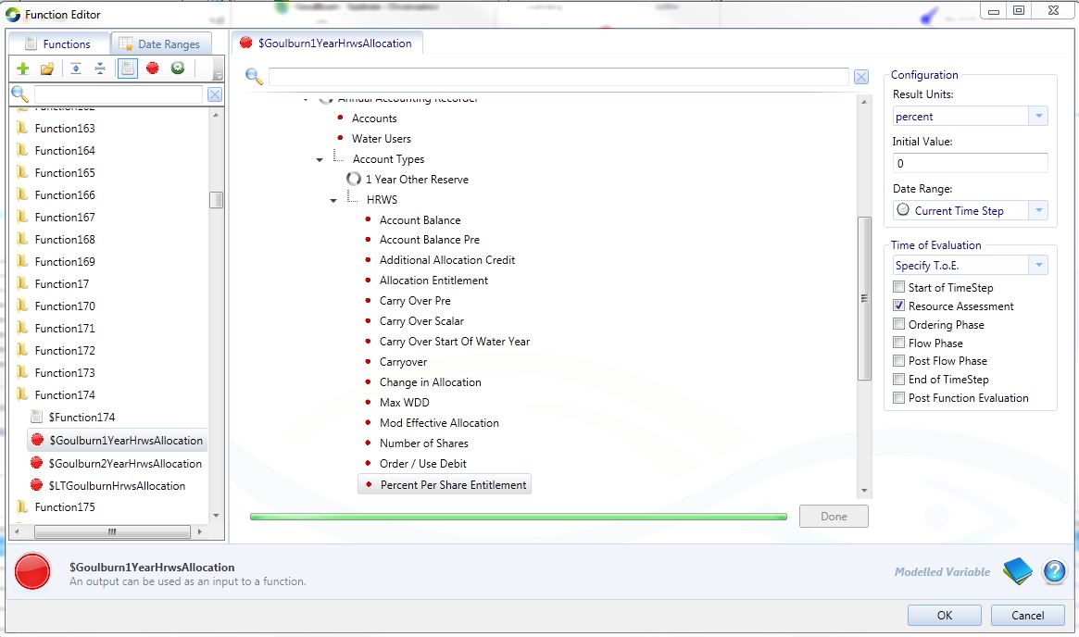
Figure 1a: Function set up to evaluate during Resource Assessment
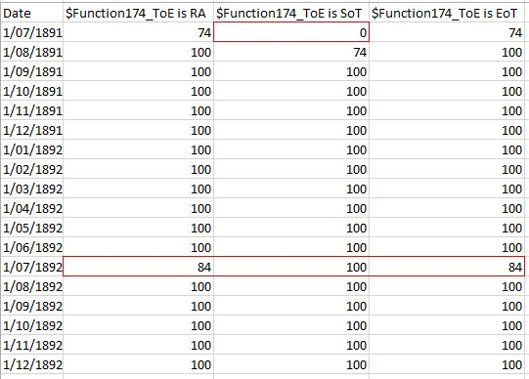
Figure 1b: Time of evaluation (ToE) comparison
While the values recorded at the EoT reflect those calculated during the current RA, the values recorded at the SoT lag by one day because:
- on the first day no RA has been undertaken yet and the function has not been evaluated, hence a value of 0 on day 1,
- for the rest of the time series the value at the SoT will be the same as the value the previous day at the EoT. Except for month 7 where this particular function has been set up to re-establish accounts in month 7, but the start of timestep is remembering the value from the day before. This is why it is important to record this function at the right time.

- This function uses the modelled variable ‘Upstream Flow’ on the ordering network, which is calculated during the Ordering phase (OP) for the Current Iteration of NETLP, as shown in Figure 2a. Figure 2b compares what the recorded results will be if this same variable is evaluated at Start of Timestep (SoT) or End of Timestep (EoT), but retaining ‘Current Iteration’ as the Date Range for evaluation. Since this Date Range (Current Iteration) is only relevant to NETLP, no values are available for recording outside of the Ordering Phase, under this configuration.

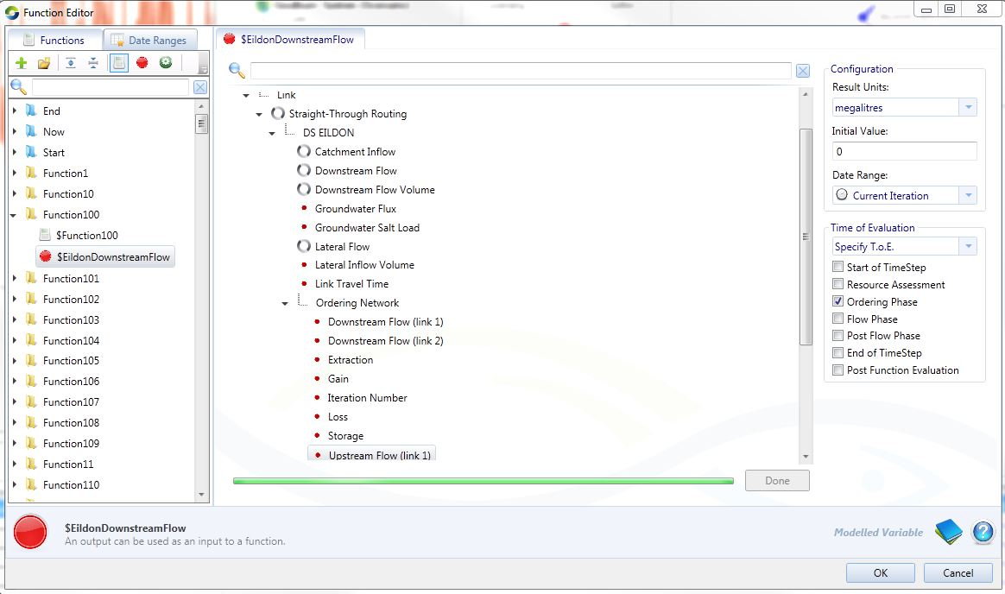
Figure 2a: Function set up to evaluate during Ordering Phase, with Date Range ‘Current Iteration’
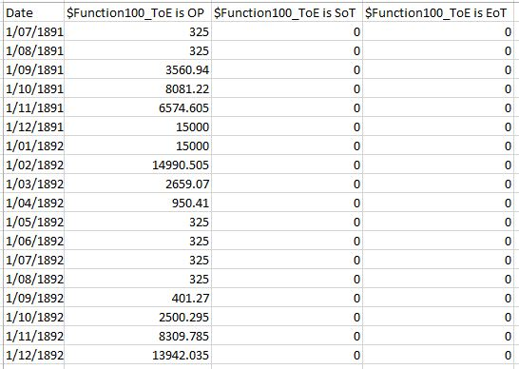
Figure 2b: Time of evaluation (ToE) comparison

